

MIDDLE EAST TECHNICAL UNIVERSITY

Electrical & Electronics Engineering Department
EE463: Static Power Conversion I
Hardware Project
Final Report

Group 5
Participants:
Yiğit AKYOL 2515484
Ahmad Parwaiz Qoram 1907336
Ismayil Ibrahimli 2489060

- Introduction

Electrical energy is widely used in residential, commercial, and industrial environments to operate a variety of electrical machines and electronic devices. However, these systems often require voltage and current levels that differ from those provided directly by the electrical grid. For this reason, power electronic converters are employed to regulate, convert, and control electrical energy in a form that is compatible with the requirements of the connected load.

The objective of this project is to design and implement a controlled rectifier system capable of driving a DC motor. The proposed system converts three-phase AC grid voltage into a controllable DC output by utilizing a diode rectifier followed by a PWM-controlled switching stage. The operating limits and performance requirements of the converter are defined by the electrical and mechanical properties of the DC motor used in this study.

This report presents the complete design process of the system. First, several possible rectifier and converter topologies are investigated and evaluated in terms of their operating principles and applicability to the given motor drive application. After selecting the most suitable topology, analytical calculations are carried out, including electrical design considerations as well as loss and thermal analyses. Based on these calculations, simulations are performed to validate the theoretical results and to observe the system behavior under different operating conditions. Finally, the hardware implementation of the designed system is described, and the experimental results obtained during the demonstration phase are presented and discussed.

- Project Specifications

The system design is constrained by the electrical and mechanical characteristics of the DC motor. The main parameters of the selected motor are listed below:

- Armature Winding: 0.8 Ω, 12.5 mH
- Shunt Winding: 210 Ω, 23 H
- Interpoles Winding: 0.27 Ω, 12 mH
- BHP: 5.5
- Rated Rpm: 1500
- Rated Voltage: 220 V
- Rated Current: 23.4 V

The input of the DC Motor driver can be 1 or 3-phase AC and the output is a maximum of 180V DC.

- Topology Comparison and Selection
  - Comparison of 3 considered topologies
    - Three Phase Diode Rectifier with Buck Converter
This is a two-stage process. First, a diode rectifier converts AC to DC, and then a buck converter steps down the voltage.
It provides a DC output with decreased ripple and is generally less expensive than thyristor topologies.

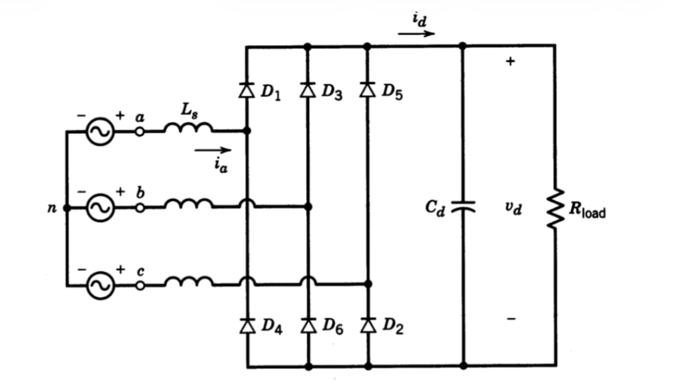
Figure 1: Three Phase Diode Rectifier Schematic
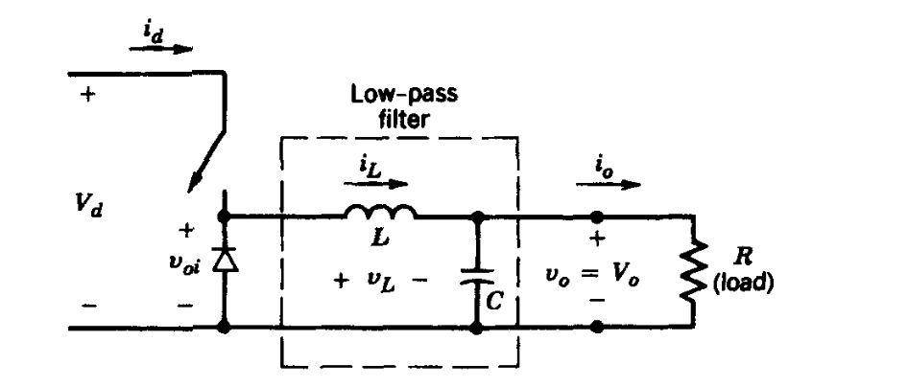
Figure 2: Buck Converter Schematic
Key Equations:
- Rectifier Output: V_{av}​=(3*sqrt(2))/π​​*V_{ll​}
- Buck Output: Vout​=V_{in}​⋅D, where D is the duty cycle.
Advantages:
- Reduced Ripple: It takes grid AC voltage as input and provides a DC output with decreased ripple compared to pure rectifier circuits.
- Cost-Effective: Although it consists of two distinct parts (rectifier and converter), this topology is generally less expensive than topologies that rely heavily on thyristors.
- Simpler Control: Only one component (the switch in the buck converter) requires a gate signal. This makes the circuit layout and signal synchronization much simpler than thyristor-based topologies, where every switch needs precise timing.
Disadvantages:
- No Inverter Mode: This topology cannot operate in inverter mode (regenerative braking). Energy flows only one way, from source to load

    - Single-Phase Thyristor Rectifier
Uses four thyristors to rectify single-phase AC to DC. The output is controlled by changing the firing angle (α).

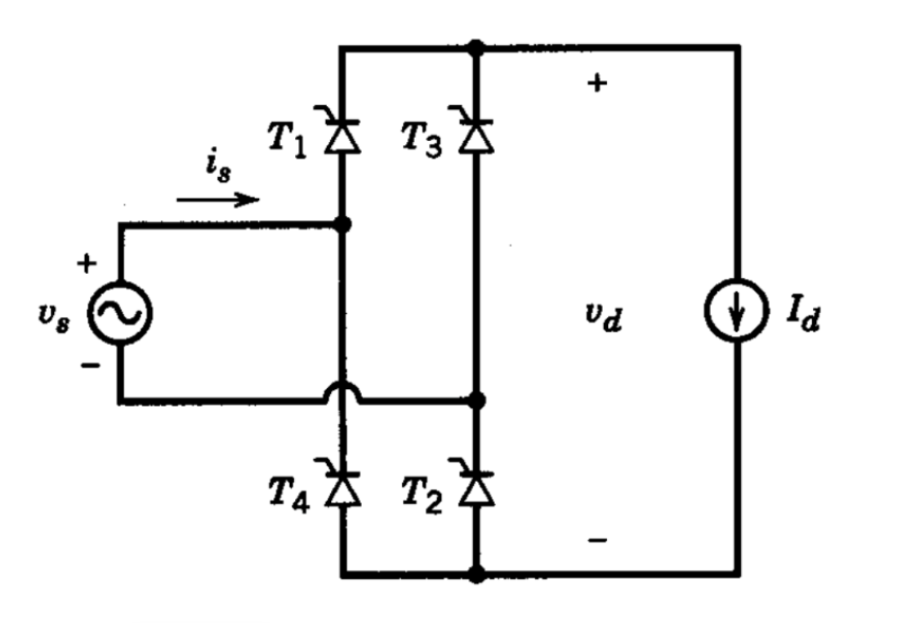
Figure 3: Single-Phase Thyristor Rectifier Schematic

Key Equation:
Output Voltage: V_{av}​=(2*sqrt(2))/π*​​V_{ph}​cosα
Advantages:
- Full Control: The output voltage can be fully controlled via the firing angles.
- Inverter Capability: Unlike the diode/buck topology, this circuit can operate in inverter mode, allowing for regenerative braking.
- Simpler than 3-Phase Thyristor: Since it uses only four thyristors, the circuit layout and gate signal synchronization are simpler than the three-phase thyristor version.
- Cost vs. 3-Phase: It is less expensive compared to the three-phase thyristor version because it requires fewer components.
Disadvantages:
- High Ripple: The output voltage ripple is high, which may require larger filtering components.
- Harmonics: It causes harmonic problems in the input current.
- Lower Voltage: The average output voltage is lower than the three-phase version.
- Complexity vs. Diode: To drive the thyristors properly, driver circuits are needed. This increases the layout complexity and component cost compared to the diode/buck option.
- Higher Cost: It generally costs more than the three-phase diode rectifier with a buck converter.

    - Three-Phase Thyristor Rectifier
Uses six thyristors. It offers smoother power delivery than the single-phase version.
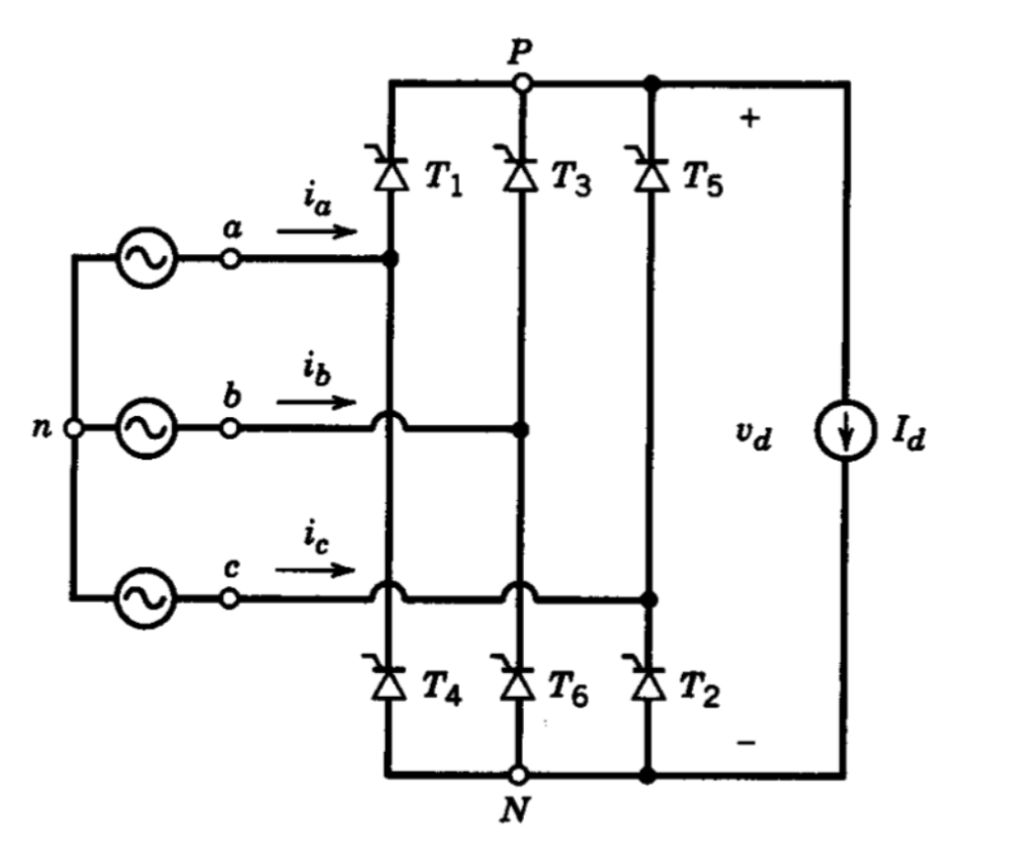
Figure 4 Three-Phase Thyristor Rectifier Schematic
Key Equation:
Output Voltage: V_{av}​=(3*sqrt(2))/π*​​V_{ph}​cosα
Advantages:
- Low Ripple: This topology results in a lower output ripple voltage compared to the single-phase case.
- High Voltage: The average output voltage is higher than the single-phase equivalent.
- Full Control: Like the single-phase version, the output voltage is fully controlled.
- Inverter Capability: It is possible to use this topology in inverter mode for regenerative braking.
Disadvantages:
- High Cost: Since six thyristors are used, it is the most expensive option.
- Complex Control: As the number of thyristors increases, the complication of generating gate signals increases as well.
- Synchronization: Synchronization of the firing signals is harder to achieve.
- Driver Requirement: The gate signals must be provided through driver circuits, which increases both complexity and cost.
- 3 different topologies are listed in Table 1. From the aspect of both THD and output voltage 3-phase topologies are advantageous.

Table 1: THD, V_{out,rms} and cost comparison
Topology type | THD of I_{IN} | V_{out,rms} | Number of elements
3 Phase Diode Rectifier + Buck Converter | ≈ 40% | (3*sqrt(2))/π*V_{ll}*D | 7 diodes+ 1 MOSFET+gate driver+passive elements
Single Phase Controlled Rectifier | ≈48.5% | (2*sqrt(2))/π*V_{IN}*cos(a) | 4 thyristors+gate driver+passive elements
3 Phase Controlled Rectifier | ≈31% | (3*sqrt(2))/π*V_{ll}*cos(a) | 6 thyristors+gate driver+passive elements

  - Topology Selection
After researching and comparing the available options, the team has decided to proceed with the Three-Phase Diode Rectifier with a Buck Converter. This decision is based on the following key factors:
- Output Quality: This topology takes the grid AC voltage and converts it to a DC output with significantly decreased ripple. This stable voltage is crucial for the efficient operation of the DC motor.
- Control Simplicity: Unlike the thyristor-based topologies which require complex synchronization for multiple switches, this design requires a gate signal for only one component (the switch in the buck converter). This makes the control circuit design much simpler and more robust.
- Cost-Effectiveness: Even though it involves two stages (rectifier and converter), this solution is less expensive than the topologies that rely on multiple controlled thyristors.
- Design Trade-off: While we acknowledge that this topology is not suitable for operating in inverter mode, the benefits of lower cost, reduced ripple, and simpler implementation outweigh the need for regenerative braking in this specific project scope.

- Mathematical Calculations, Design, and Simulation
Considering the project requirements, the maximum DC input voltage of the DC motor is 180 V, Vout,max=180 V. For this reason, we chose a maximum duty cycle of 0.8, Dmax=0.8, to satisfy the limitation of the DC voltage, because higher duty cycle values are challenging to achieve. Nominal DC voltage that the three-phase diode rectifier must supply is calculated as follows.
$$V_{DC,rect}=\frac{V_{o,max}}{D_{max}}=\frac{180}{0.8}=225 V$$

Using the average DC output voltage of a three-phase diode rectifier, we must calculate the input three-phase voltage needed to satisfy the requirements. The calculations for this process are provided below.
$$V_{DC,average}=1.35 x V_{LL}$$
$$V_{LL}=\frac{V_{DC,rect}}{1.35}=166.7 V$$
$$V_{phase}=\frac{166.7}{\sqrt{3}}=96.5 V approximately$$
$$V_{phase,rms}=96.5 x\sqrt{2}=136.1 V$$
Therefore, it is concluded that a phase rms voltage of 136.1 V must be used to obtain the DC output that will be used to drive the motor. Moreover, to get a smooth and low ripple DC output, an output capacitor must be used after the diode rectifier.
For the buck converter design, a high-side driven IGBT, a free-wheeling diode, and a gate driver circuit are decided to be used. Firstly, the specifications of the buck converter design are given as follows.
$$V_{out,max}=180 V, D_{max}=0.8, and P_{max}=2 kW$$

$$I_{out,max}=\frac{2 kW}{180 V}=11.11 A$$
$$Choosing a switching frequency, f_{s}=1.5 kHz$$

Because the buck converter will be used to drive a DC motor with an armature winding of 0.8 Ω and 12.5 mH. Thus, an additional inductor and capacitor are not needed in the buck converter design.
The three-phase diode rectifier and the buck converter are simulated in Simulink as shown in Figure 5. The gate driver control circuit is not simulated in this part; only a constant PWM signal is given as the gate signal at this stage. Later on, the control circuit will be explained.
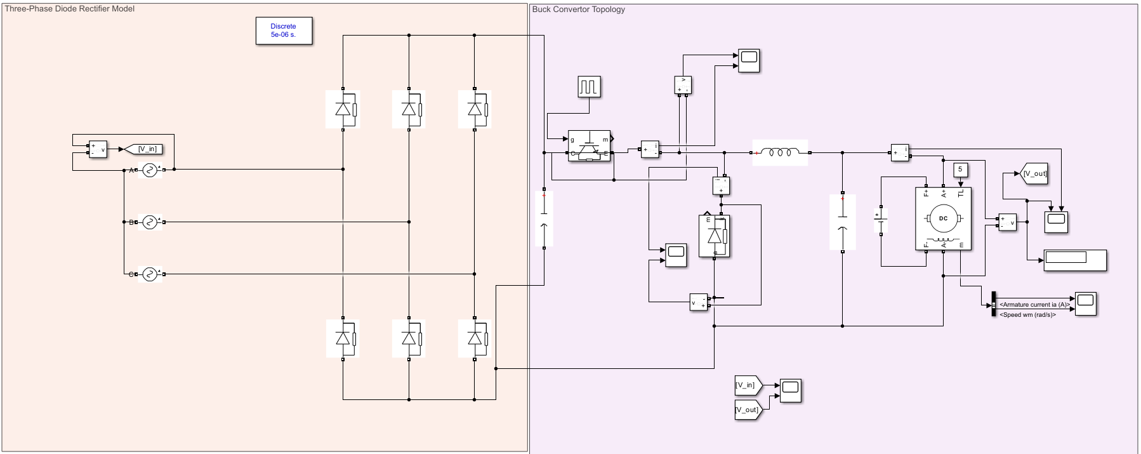
Figure 5: Three-Phase Diode Rectifier and Buck Converter Topology
The rectifier’s input and output voltage and current waveforms are observed as shown in Figures 6 and 7.
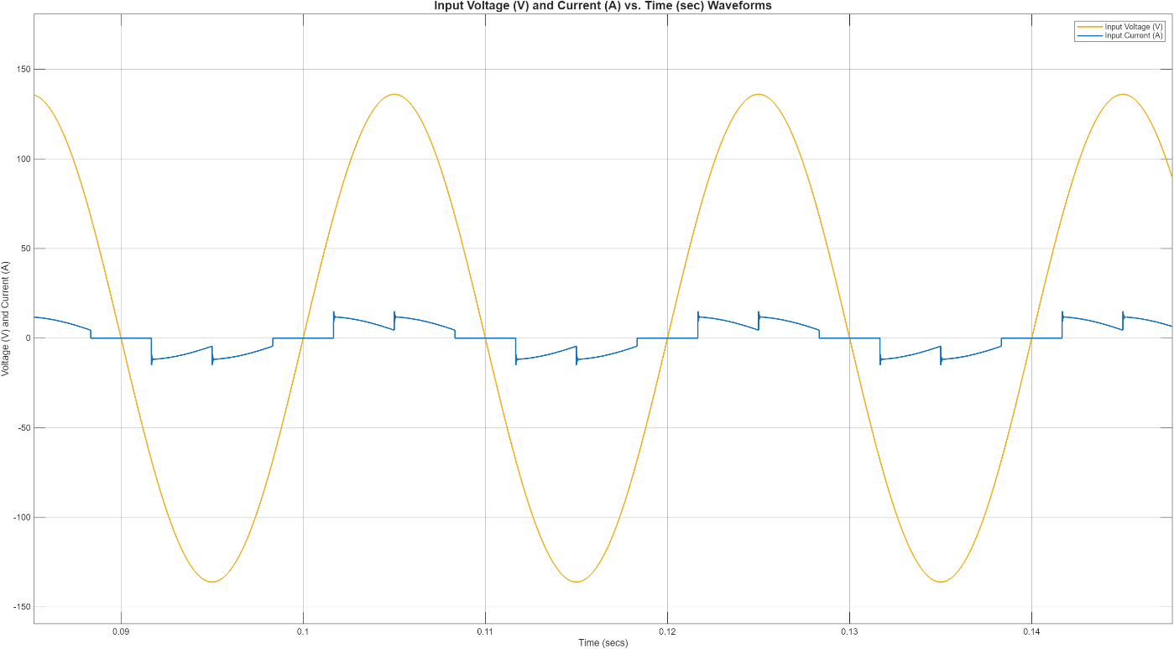
Figure 6: Rectifier Input Voltage and Current Waveforms

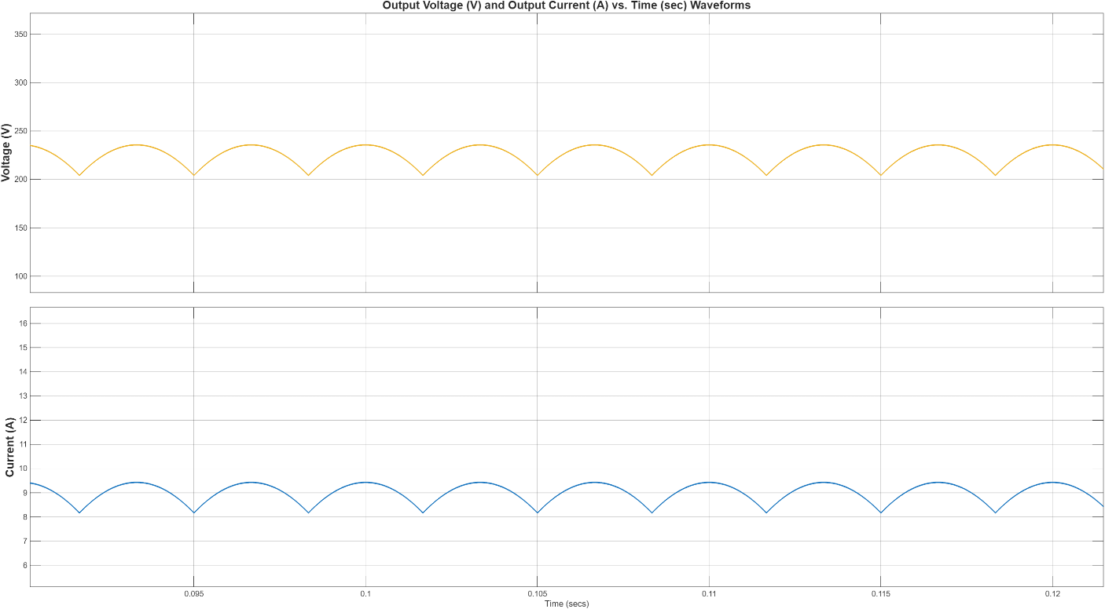
Figure 7: Rectifier Output and Current Waveforms
When the output voltage and current values are observed, it can be seen that a voltage of approximately 225 V is suitable for obtaining a 180 V DC output at the buck converter side.
In order to observe the behavior of the circuit in different duty cycle values, two different cases are investigated. The maximum duty cycle value, 0.8, must be achieved with a soft start because the inrush current may damage the components. The 0.2 and 0.8 duty cycle values are used to observe the design characteristics. The output voltage and current, IGBT voltage and current, and the free-wheeling diode voltage and current waveforms are examined to decide the components and the operation quality. The waveforms for 0.2 and 0.8 duty cycles are shown in Figures 8 to 13.

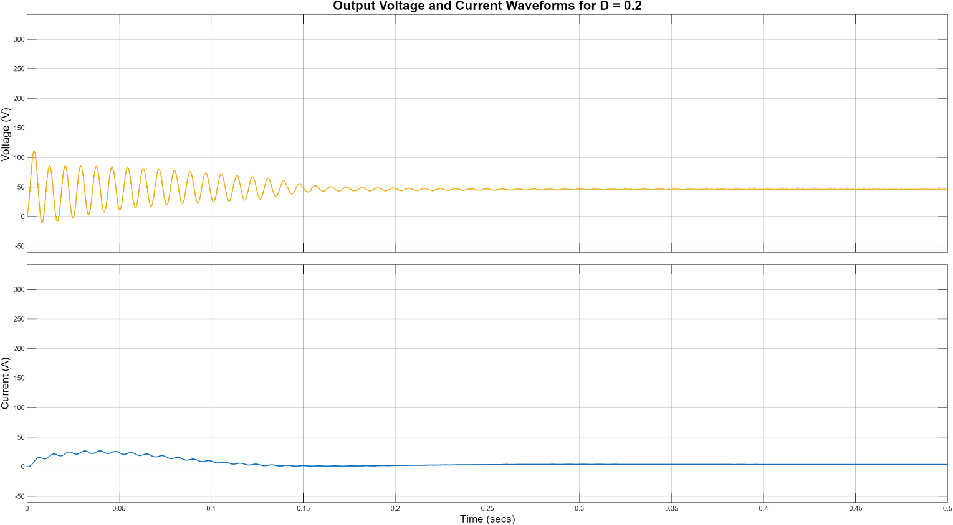
Figure 8: Output Voltage and Current Waveforms for D=0.2
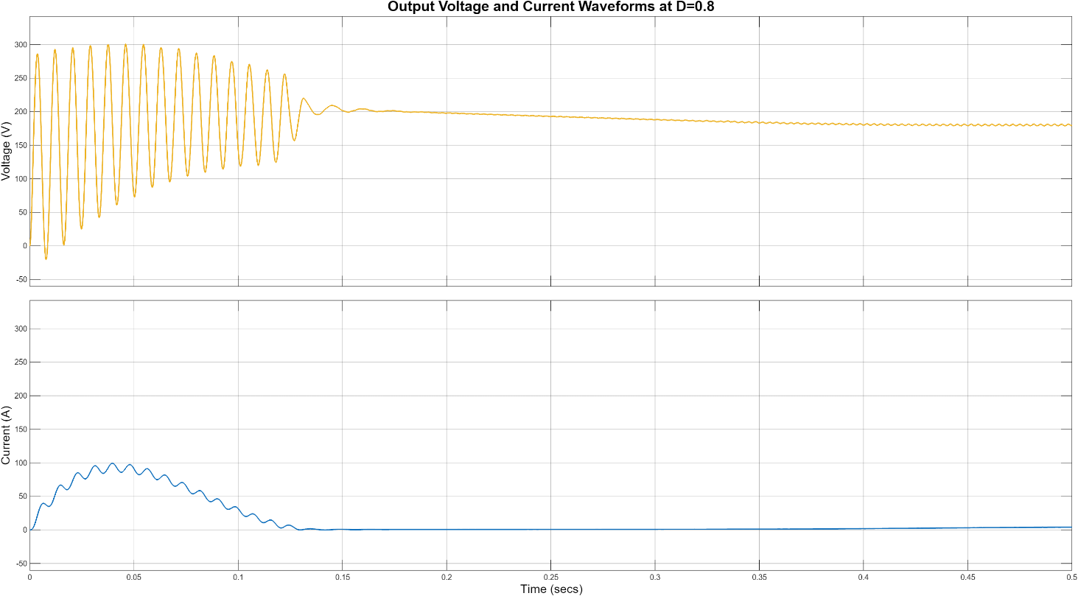
Figure 9: Output Voltage and Current Waveforms at D=0.8

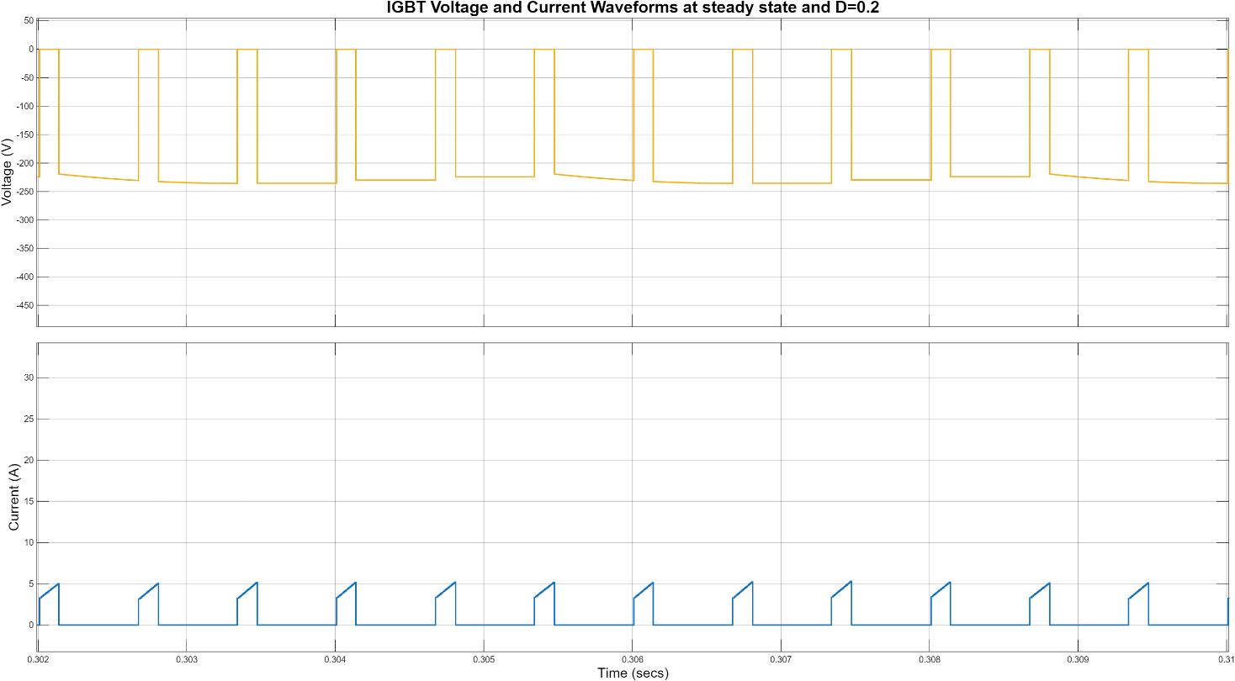
Figure 10: IGBT Voltage and Current Waveforms at D=0.2

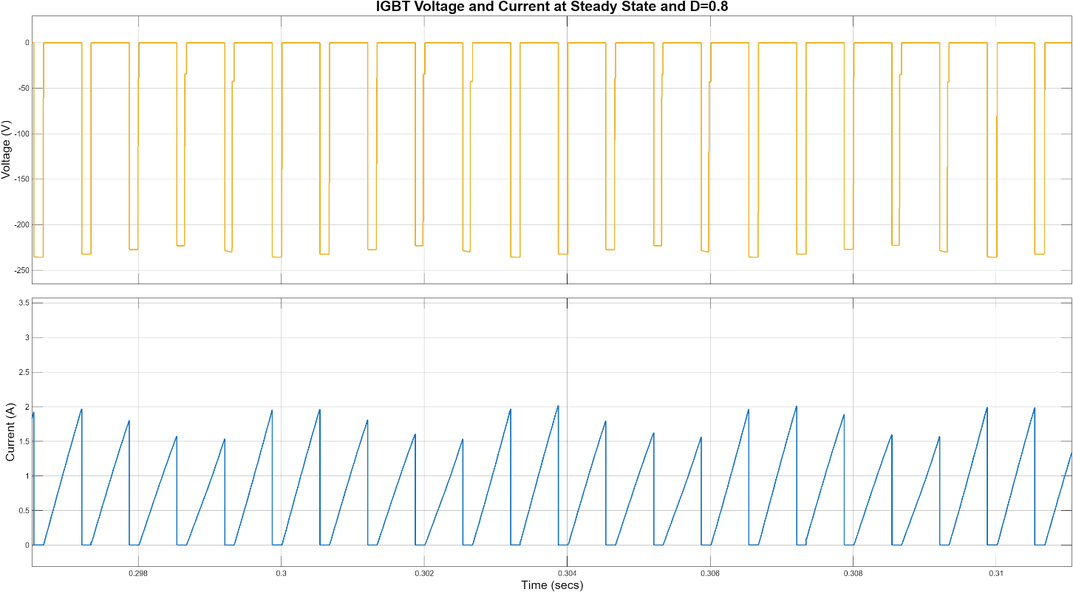
Figure 11: IGBT Voltage and Current Waveforms at D=0.8

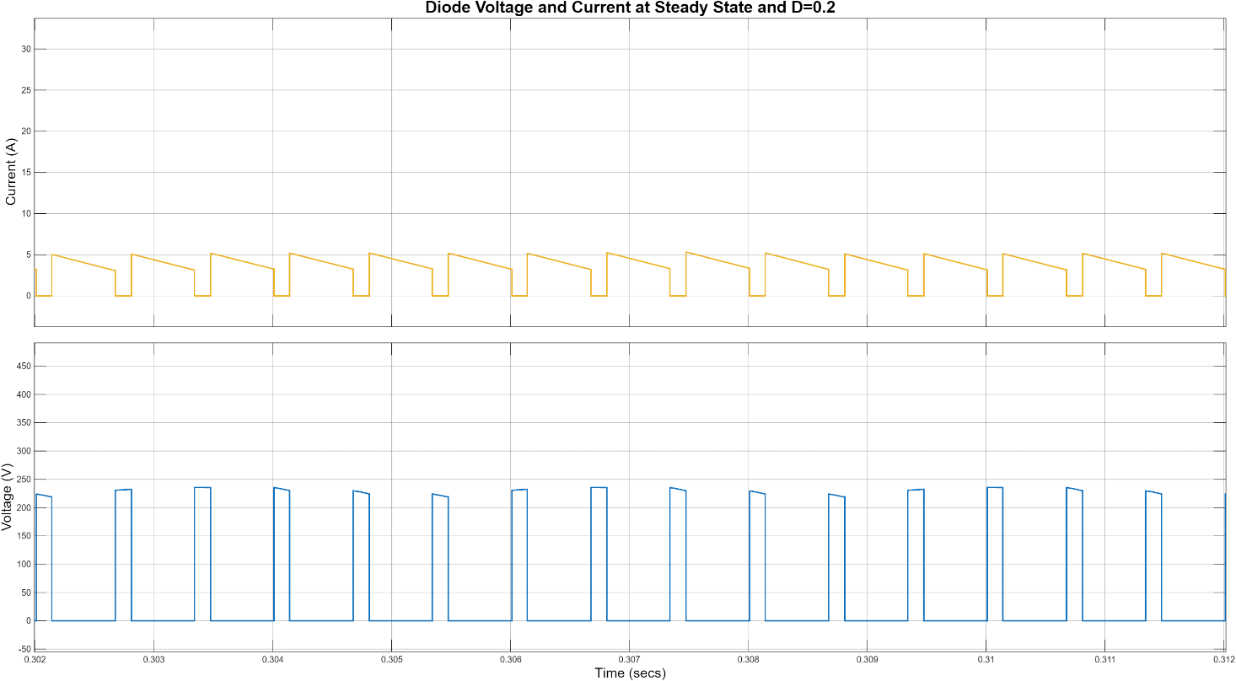
Figure 12: Diode Voltage and Current Waveforms at D=0.2
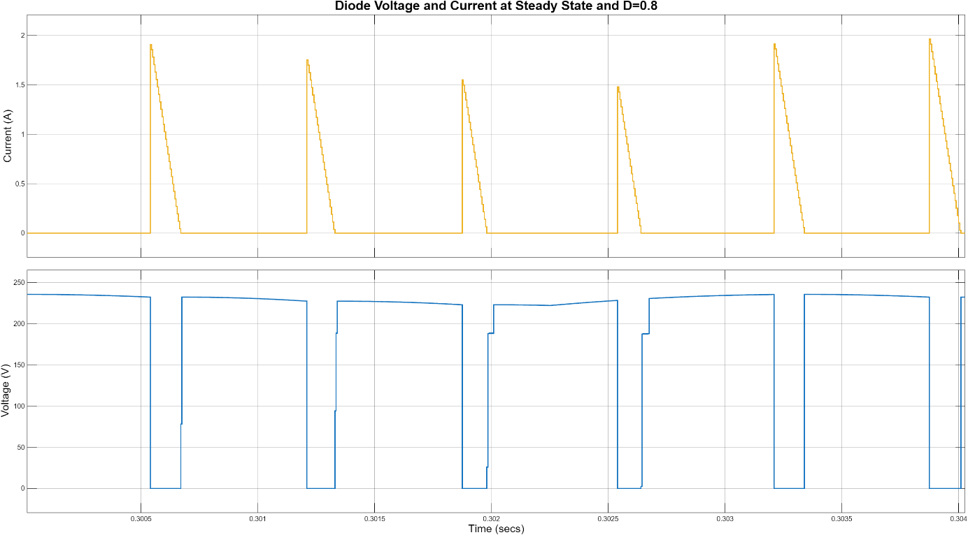
Figure 13: Diode Voltage and Current Waveforms at D=0.8

As can be seen from the steady state graphs, it can be concluded that while a duty cycle of 0.8 is proper to obtain a 180 V DC output, the inrush current is a problem. That is why a 0.2 duty cycle case is also simulated and will be used in the later parts. Moreover, it can also be seen that the simulation operates perfectly well, such that the design is suitable for implementation.
Moreover, at the maximum duty cycle, 0.8, the output voltage is approximately 180 V, which satisfies the DC motor driving operation.
In this part, the simulations of the design are conducted. Using these simulations, the components will be selected accordingly.

- Component Selection and Control Circuit

In this part, the selection of the component and the control circuit will be explained. As indicated earlier, the three-phase diode rectifier and buck converter topologies are used in this project.

  - Three-Phase Diode Rectifier
Firstly, the input and output voltage and current waveforms are observed, and a diode rectifier with a voltage rating greater than 500 V and a current rating greater than 30 A is decided to be suitable for the design. Thus, the three-phase diode rectifier model “SKBPC5016” is chosen with a voltage rating of 1600 V and a current rating of 50 A. It is concluded that this rectifier is the safest solution for the design, and the safety margins are considered. Moreover, to obtain a stable and low ripple output at the rectifier, two 220 µF, 400 V capacitors will be used in parallel. The DC link capacitors ensure the low ripple operation and the voltage rating limits, as examined in the waveforms. These components conclude the three-phase diode rectifier part of the design

  - Buck Converter

The buck converter consists of an IGBT and a free-wheeling diode. When the waveforms with different duty cycles are observed, it can be seen that for the 0.2 duty cycle case and 0.8 duty cycle case, the maximum inrush currents are approximately 25 A and 90 A, respectively. Because a soft start solution will be implemented, the inrush currents will not create a problem. However, in order to stay within the safe limits, an IGBT with a current rating greater than 25 A is chosen. Moreover, an IGBT with a voltage rating greater than 500 V is preferred in this case. Therefore, the model “IXGH24N60C4D1” is chosen with 30 A and 600 V ratings. The reason IGBT is used is that the switching frequency is chosen to be 1.5 kHz, such that the switching loss will be minimized and the switch is able to operate efficiently.
Considering the same reasons, a free-wheeling diode with ratings of 30 A and 600 V is chosen, “DSEI30-06A”. The chosen diode is concluded to be suitable, considering the simulation results.

  - Control Circuit
The control solution selected in the design is digital, and for this purpose, the “Arduino UNO R3” board is used. To power the Arduino board from the DC power supply, a “LM2596” voltage regulator is also used, and the voltage is converted to 5 V from 12 V. After that, an algorithm is used to obtain a PWM signal from the Arduino. The code used can be seen in Appendix A. The soft start is obtained by using a 10 kΩ POT, and the duty cycle is controlled between 0 and 0.8. Therefore, it is increased slowly by hand in order to prevent the inrush current and damage the components.
The challenging part of the control circuit is to isolate the IGBT gate and the rest of the circuit (HV and LV sides). For this purpose, a “TLP250” gate driver is used. One side of the driver takes signals from the Arduino, and the other side conveys the signals to the IGBT gate. The sides are powered from different sources, i.e., isolated. To achieve the isolation barrier, a “R1S-1212”, 12 V - 12V isolated converter is used. An isolated 12 V is obtained from the DC source in this way, and the gate driver is powered. The gate signal is achieved to be floating by connecting the TLP250 pins to the gate with a 10 Ω resistor and the emitter of the IGBT. Therefore, the PWM signal is transferred to the gate with an isolation barrier, and the IGBT is driven.
The datasheets of all the components used can be seen in Appendix B.

  - Used Components

Table X. Used Components
Components | Cost
Bridge Rectifier - SKBPC5016 | 226,36 TL
IGBT - IXGH24N60C4D1 | 156,27 TL
Diode - DSEI30-06A | 121,18 TL
Capacitor x 2 - 220µF/400V | 173,12 TL
Arduino Uno R3 | 305,50 TL
Optocoupler - TLP 250 | 47,92 TL
R1S-1212 | 47,30 TL
DC-DC Step Down - LM2596 | 103,68 TL
Potentiometer | 5,66 TL
Stone Resistor | 6,21 TL
Heatsink x2 | 175,84 TL
Stripboard | 60 TL

Total Cost = 1.429,04 TL

- Thermal Calculations
Effective thermal management is critical to preventing semiconductor degradation and ensuring the longevity of power electronics. The following calculations determine the required thermal resistance for the heatsinks based on a switching frequency of 1.5 kHz and a duty cycle of 0.8 ( around 10A ).

  - Bridge Rectifier
The bridge rectifier's power dissipation is primarily conduction loss. Using the forward voltage drop V_{f​} and the simulated average current, the power loss is recalculated as follows:
- Parameters: V_{f​} = 1.28V, I_{avg​}= 7.55A, D = 0.8, R_{th,ch}​=0.5∘C/W
- P_{loss}​ = 6 × V_{f}​ × I_{avg​} × D = 6 × 1.28V × 7.55A ×0.8 ≈ 46.39W
- Heatsink Requirement: To maintain a safe junction temperature T_{j​} of 100∘C at an ambient temperature T_{a}​ of 25∘C:
R_{eq} ​= (T_{j}​−T_{a}​)​/P_{loss​} = 100−25​/46.39 ≈ 1.62∘C/W
R_{heatsink​} = R_{eq​}−R_{th,ch}​ = 1.62−0.5 = 1.12∘C/W

  - IGBT Module

For the IGBT, we must account for both conduction losses (affected by duty cycle) and switching losses (proportional to frequency).
- P_{cond} ​= 1.5V × 19.60A × 0.8 = 23.52W
- P_{sw}​ = 1.5kHz × 1.46mJ = 2.19W
- P_{total​} = 23.52+2.19 = 25.71W
- Thermal Calculation: Targeting T_{j​} = 100∘C with R_{th,ch} ​= 0.8∘C/W:
R_{eq​} = (100−25)​/25.71 ≈ 2.92∘C/W
R_{heatsink​}=2.92−0.8=2.12∘C/WT

  - Power Diode
The diode experiences a significant increase in switching loss due to the higher frequency and the reverse recovery characteristics.
- P_{cond​} = 1.6V × 19.60A × 0.8 = 25.09W
- P_{sw​} = 220V × 10A × 50ns × 1.5kHz × 0.5 = 0.0825W
- P_{total​} = 25.09 + 82.5 = 107.59W
Thermal Calculation: Targeting T_{j​}=125∘C with R_{th,ch​}=1∘C /W:
R_{eq}​=(125−25)/107.59 ​≈ 0.93∘C /W
Since R_{eq}​ (0.93) is less than the case-to-sink resistance (1.0), this component requires active cooling or a significantly larger heatsink with a negative margin for R_{heatsink​}.

- Implementation Process

Throughout the project, the hardware design was developed with an emphasis on practicality and industrial relevance. From the beginning of the design process, the team planned to implement the system on a stripboard, as this approach allows for flexible layout design while remaining suitable for laboratory-scale power electronic applications. In order to achieve a clean and reliable implementation, careful planning was carried out before the assembly stage.

Initially, the physical dimensions of all components were examined to ensure proper placement and sufficient spacing on the stripboard. Special attention was given to power components that are subject to thermal stress, such as the rectifier, IGBT, and free-wheeling diode. These components were identified in advance and positioned to allow the use of appropriate heatsinks and adequate airflow. Following this evaluation, the locations of all components were determined in a logical and optimized manner, considering both electrical connectivity and mechanical stability.

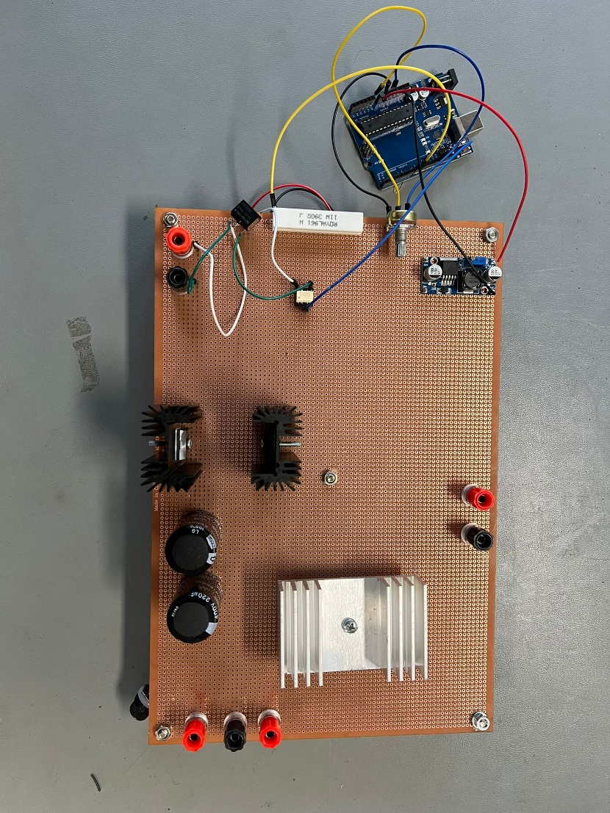
After finalizing the layout, the soldering and cabling processes were performed with care to minimize wiring errors and to ensure robust electrical connections. The completed stripboard implementation reflects the planned design approach and can be observed in the corresponding Figures 14, 15, and 16.
Figure 14:Top view of the DC Motor Driver

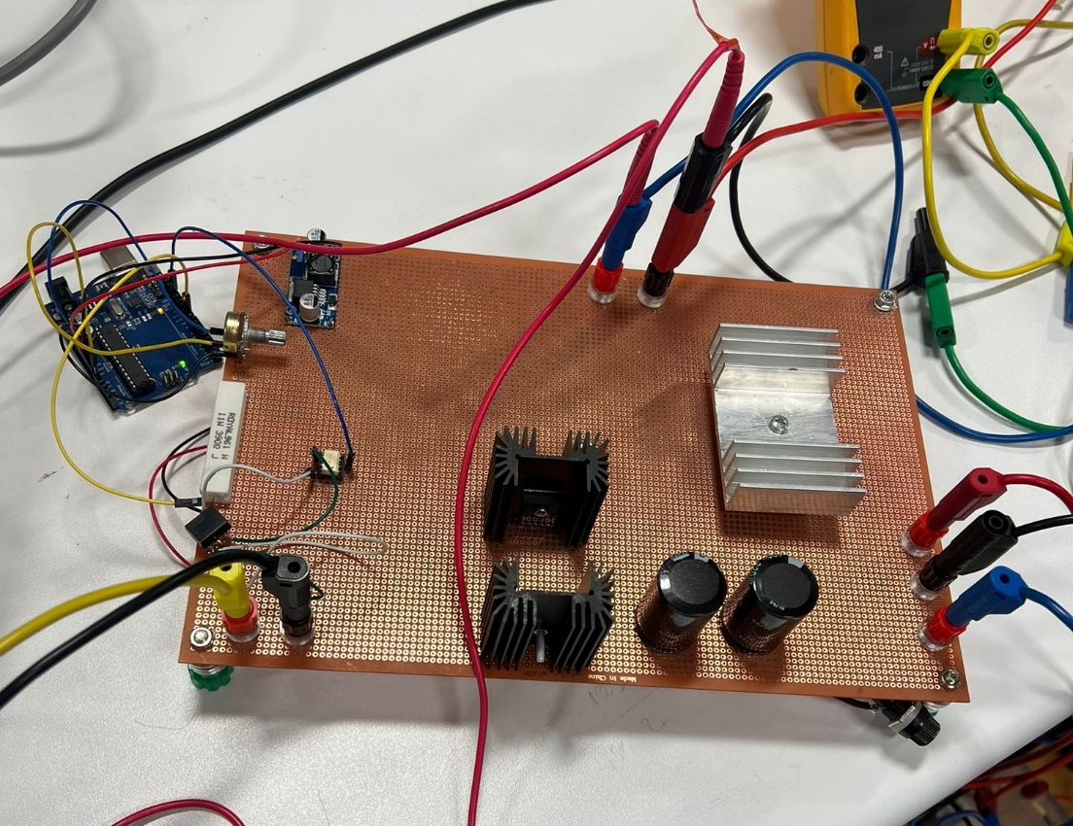
Figure 15: Side view of the DC Motor Driver

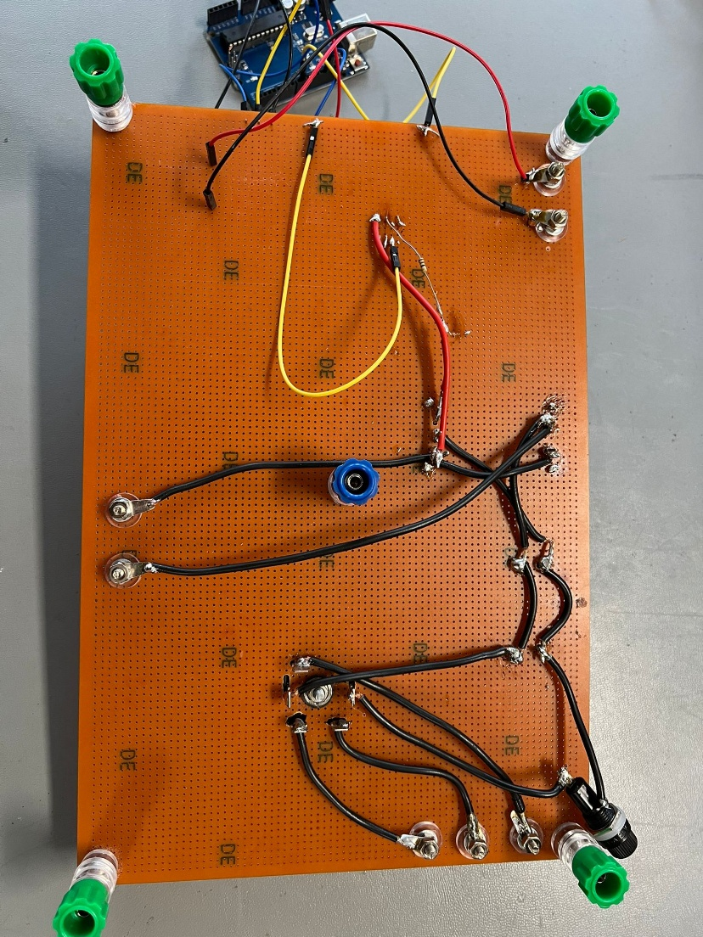
Figure 16: Back view of the DC Motor Driver

- Demo Day

During the demonstration session, the designed system was tested under different operating conditions to evaluate its performance. The tests were carried out gradually in order to ensure safe operation and to observe the behavior of the system at each stage. As an initial step, the converter was operated with a purely resistive load. Under this condition, the circuit operated as expected and produced the desired DC output voltage. An output voltage of approximately 180 V was observed, confirming the correct operation of the rectifier and DC-link stages.
After verifying the operation with the resistive load, the DC motor was connected to the system. The PWM duty cycle was increased slowly to provide a smooth startup and to avoid excessive current stress. The motor responded properly to the applied control signal, and stable operation was achieved as the duty cycle was increased. The system was able to drive the motor close to its rated operating voltage, which was approximately 180 V, in line with the design expectations.
Once the rated operating point was reached, the motor was allowed to run continuously for five minutes. During this time, the system continued to operate in a stable manner without any interruptions or unexpected behavior. The temperature of the main power components was monitored, and after five minutes of operation, the measured temperature reached approximately 70°C, which remained within acceptable limits for safe operation.

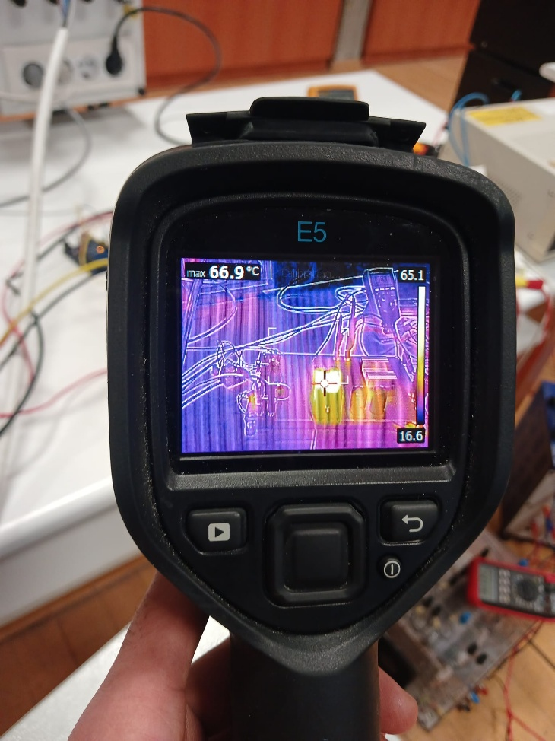
Figure 17: Thermal Measurement of the System

In addition to normal operating tests, the system was also evaluated as part of the bonus task. In this test, the DC motor driven by the converter was mechanically coupled to an AC machine supplying a 2 kW electric kettle. The drive system was able to deliver sufficient power to the coupled setup, allowing the kettle to operate continuously for more than five minutes. As a result, the water inside the kettle was successfully boiled, and the bonus task was completed successfully.
Overall, the demonstration results showed that the proposed system operates reliably under both nominal and higher power conditions. The successful completion of the bonus task further demonstrated the robustness of the hardware implementation and the capability of the designed converter to deliver sustained power in practical operation.

- Conclusion
In this project, a controlled rectifier system was designed and implemented to drive a DC motor using a three-phase AC supply. After examining various converter topologies, a three-phase diode rectifier combined with a PWM-controlled switching stage was selected due to its simplicity, reliability, and suitability for the given application. Analytical calculations were performed to determine the electrical operating conditions, power levels, losses, and thermal limitations of the system, which formed the basis of the overall design.
Simulation studies were carried out to validate the analytical results and to observe the behavior of the system under different operating conditions. The obtained simulation plots and waveforms were consistent with the expected theoretical behavior and provided confidence before proceeding to the hardware implementation stage. Since the simulation results aligned well with the calculations, the design did not require significant structural changes.
The hardware implementation was realized on a stripboard with careful consideration of component placement, grounding, and thermal management. The experimental tests demonstrated that the system operates reliably under various load conditions while maintaining stable electrical and thermal performance. The successful operation of the system under increased power demand, including the completion of the Tea Bonus task, further confirmed the robustness and practical capability of the proposed design.
Overall, the objectives of the project were successfully achieved. The designed system provided controlled DC motor operation from an AC source and demonstrated good agreement between analytical calculations, simulation results, and experimental behaviour. In addition to fulfilling the technical requirements, the project offered valuable hands-on experience in power electronics design, simulation, and hardware implementation, reinforcing the theoretical concepts covered throughout the course.

- Appendix A
// Arduino UNO: ~1.5 kHz PWM on D9 (Timer1)
// Pot on A0 controls duty (0..80%)

#define PWM_PIN 9
#define POT_PIN A0

#define PWM_TOP 1333 // ~1.5 kHz with prescaler 8
#define DUTY_MAX 1067 // 80% of 1334 counts

void setup() {
pinMode(PWM_PIN, OUTPUT);

// ---- Timer1: Fast PWM, TOP=ICR1, non-inverting on OC1A (D9) ----
TCCR1A = 0;
TCCR1B = 0;
TCNT1 = 0;

ICR1 = PWM_TOP; // sets frequency
OCR1A = 0; // start at 0% duty

TCCR1A |= (1 << COM1A1); // OC1A non-inverting
TCCR1A |= (1 << WGM11);
TCCR1B |= (1 << WGM12) | (1 << WGM13); // Fast PWM, mode 14

TCCR1B |= (1 << CS11); // prescaler = 8
}

void loop() {
int pot = analogRead(POT_PIN); // 0..1023

// 0..80% duty
uint16_t duty = (uint32_t)pot * DUTY_MAX / 1023;

// soft start
static uint16_t duty_filt = 0;
duty_filt = (duty_filt * 7 + duty) / 8;

OCR1A = duty_filt;

delay(5);
}

- Appendix B

SKBPC5016 Datasheet
https://panda-bg.com/resources/prod_2163_3206-080127-three-phase-rectifier-bridge-skbpc5016-50a-1600v.pdf

LM2596 Datasheet
https://www.ti.com/lit/ds/symlink/lm2596.pdf

TLP250 Datasheet
https://toshiba.semicon-storage.com/info/TLP250_datasheet_en_20190617.pdf?did=16821&prodName=TLP250

R1S-1212 Datasheet
https://g.recomcdn.com/media/Datasheet/pdf/.f8kdCVYZ/.tc9674cc7a356600e3b03/Datasheet-35/R1S_R1D.pdf

